**REVIEW #2**

**COMMON CORE EXAM QUESTIONS**

**UNIT 3**

**PART II** (2 points)

1. A family is traveling from their home to a vacation resort hotel. The table below shows their distance from home as a function of time.



Determine the average rate of change between hour 2 and hour 7, including units.

**PART I** (2 points)

2. The graph below models the height of a remote-control helicopter over 20 seconds during flight.



Over which interval does the helicopter have the *slowest* average rate of change?

(1) 0 to 5 seconds (3) 10 to 15 seconds

(2) 5 to 10 seconds (4) 15 to 20 seconds

**PART I** (2 points)

3. Which graph shows a line where each value of *y* is three more than half of *x*?



**PART I** (2 points)

4. A plumber has a set fee for a house call and charges by the hour for repairs. The total cost of her services can be modeled by .

Which statements about this function are true?

1. A house call fee costs $95.

II. The plumber charges $125 per hour.

III. The number of hours the job takes is represented by *t*.

(1) I and II, only (3) II and III, only

(2) I and III, only (4) I, II, and III

**PART I** (2 points)

5. What is the domain of the relation shown below?



(1)  (3) 

(2)  (4) 

**PART II** (2 points)

6. The graph below shows two functions,  and . State all the values of *x* for which .



**PART IV** (6 points)

7. Zeke and six of his friends are going to a baseball game. Their combined money totals $28.50. At the game, hot dogs cost $1.25 each, hamburgers cost $2.50 each, and sodas cost $0.50 each. Each person buys one soda. They spend all $28.50 on food and soda.

Write an equation that can determine the number of hot dogs, *x*, and hamburgers, *y*, Zeke and his friends can buy.

Graph your equation on the grid below.



Determine how many different combinations, including those combinations containing zero, of hot dogs and hamburgers Zeke and his friends can buy, spending all $28.50. Explain your answer.

**PART IV** (6 points)

8. Franco and Caryl went to a bakery to buy desserts. Franco bought 3 packages of cupcakes and 2 packages of brownies for $19. Caryl bought 2 packages of cupcakes and 4 packages of brownies for $24. Let *x* equal the price of one package of cupcakes and *y* equal the price of one package of brownies.

Write a system of equations that describes the given situation.

Graph the system of equations.

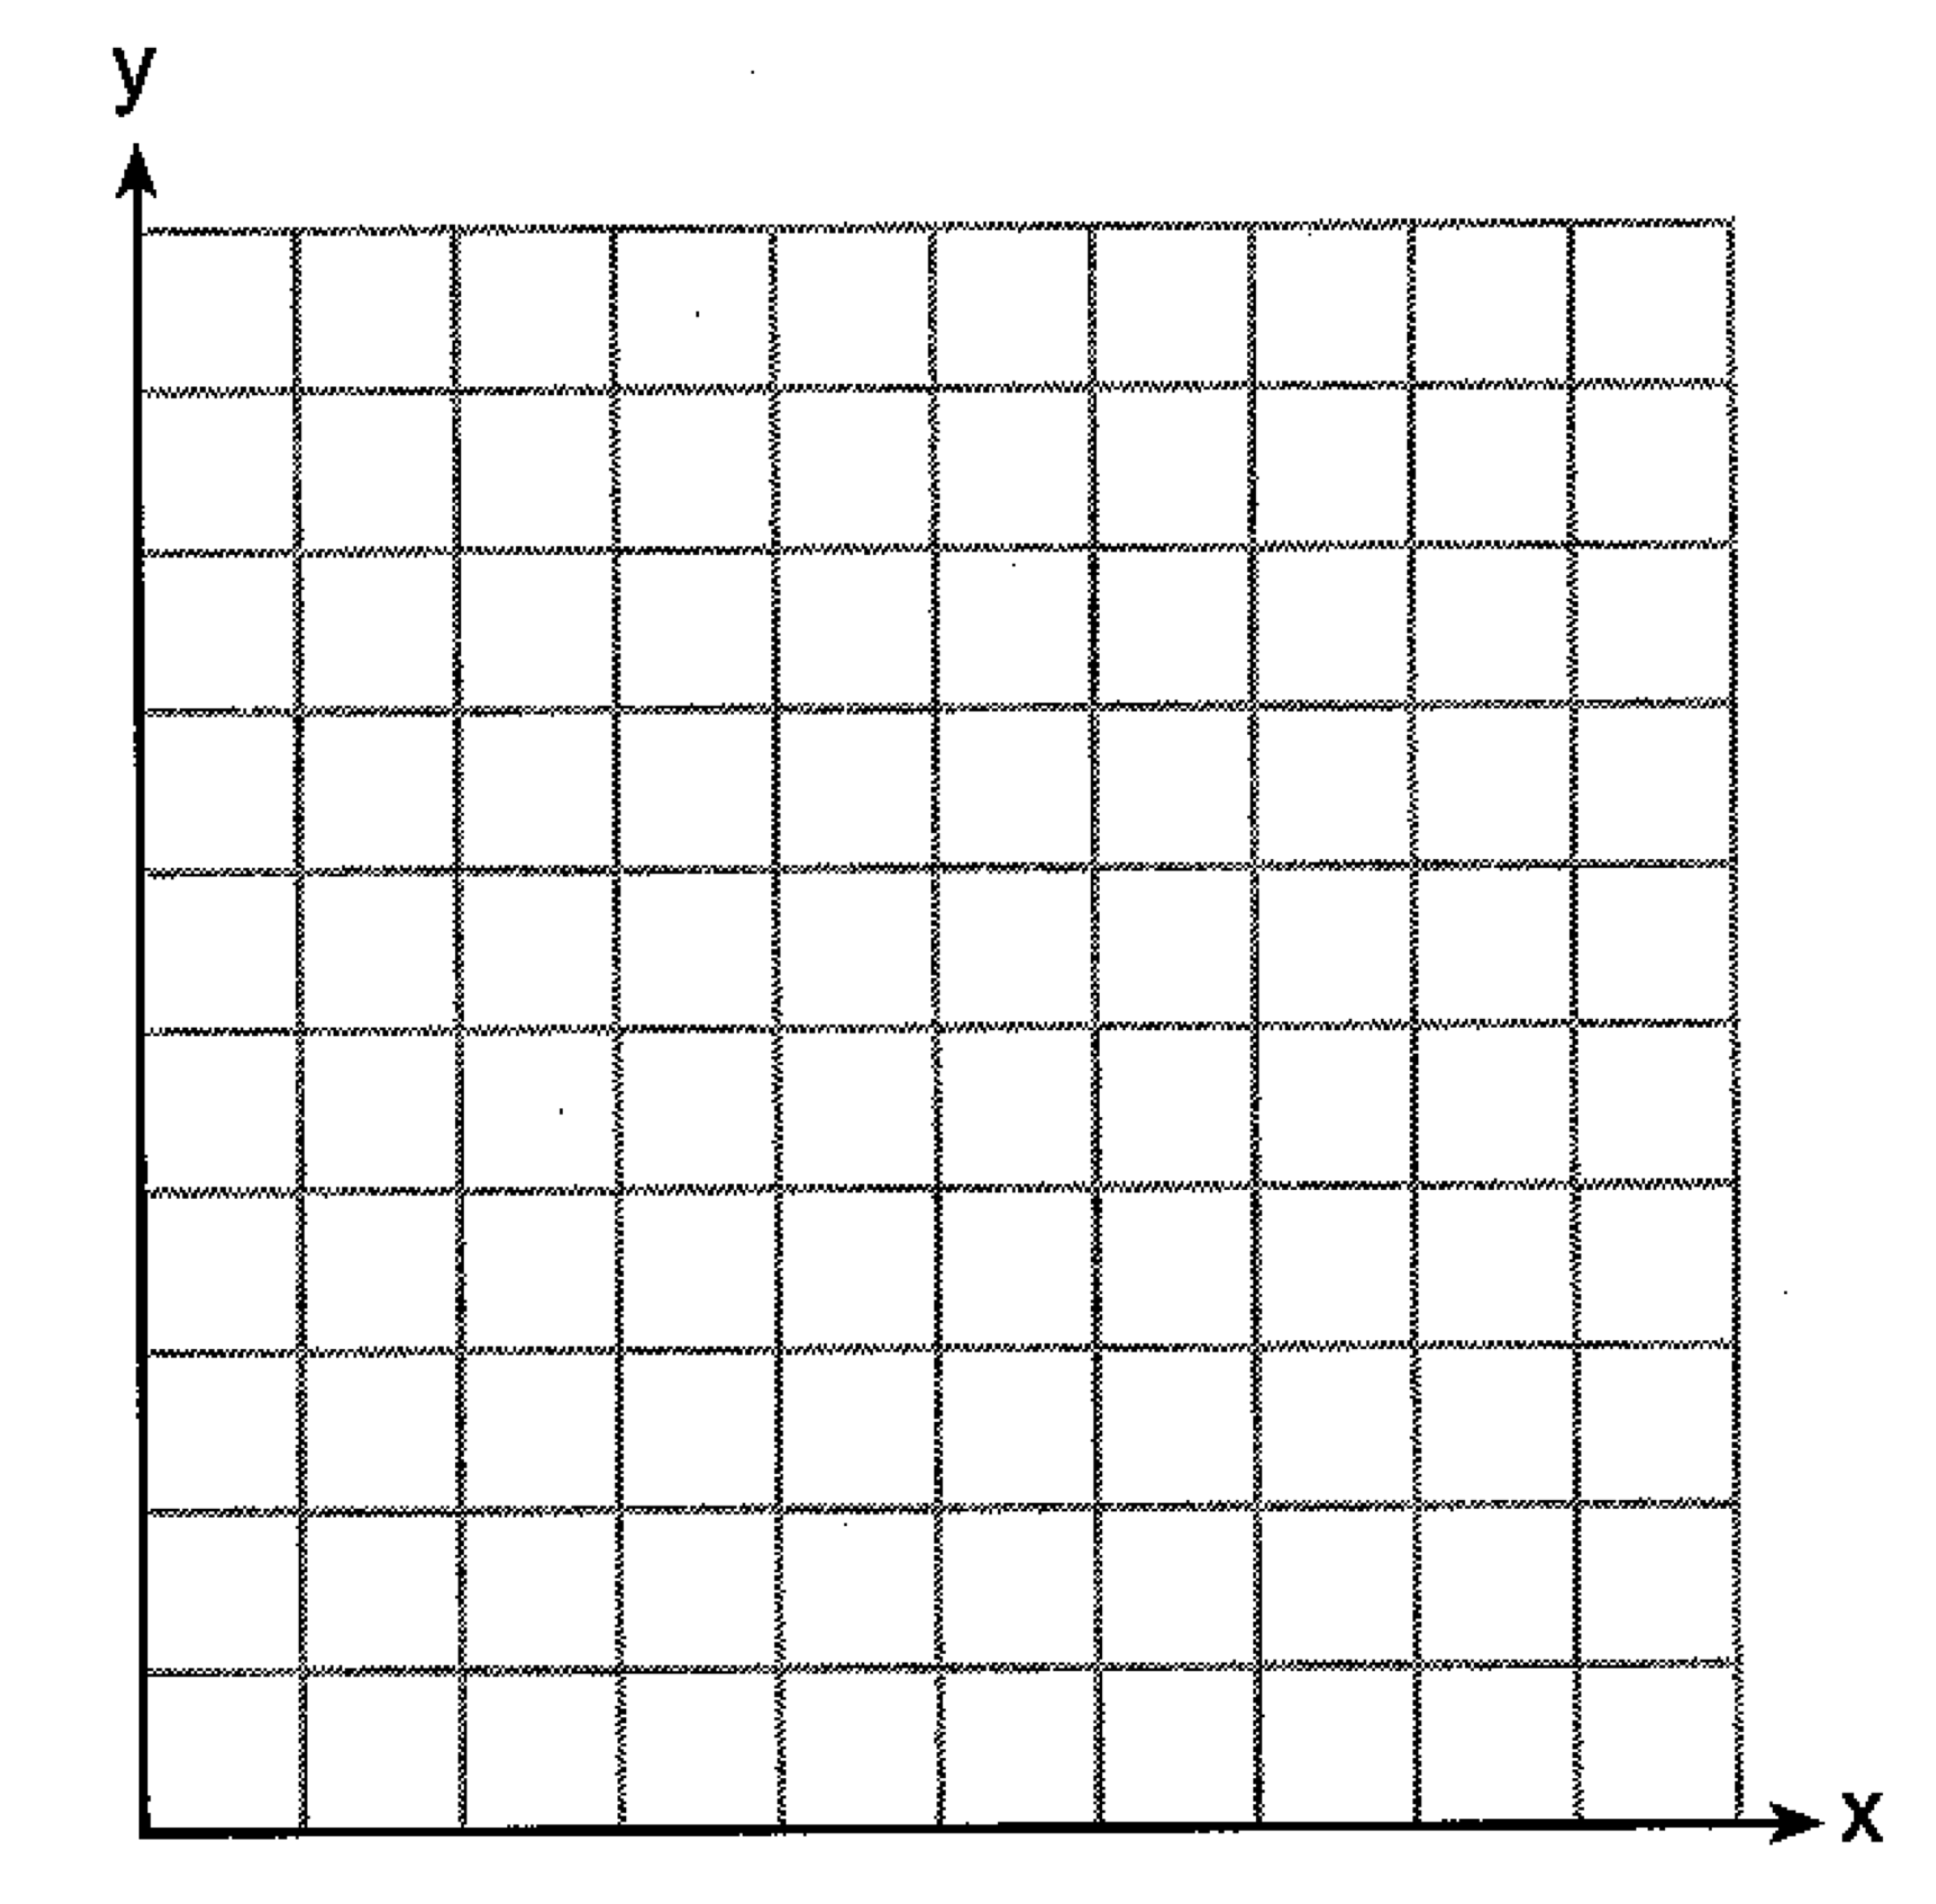

Determine the exact cost of one package of cupcakes and the exact cost of one package of brownies in dollars and cents. Justify your solution.

**PART IV** (6 points)

9. Central High School had five members on their swim team in 2010. Over the next several years, the team increased by an average of 10 members per year. The same school had 35 members in their chorus in 2010. The chorus saw an increase of 5 members per year.

Write a system of equations to model this situation, where *x* represents the number of years since 2010.

Graph this system of equations on the set of axes below.



Explain in detail what each coordinate of the point of intersection of these equations means in the context of this problem.

**UNIT 4**

**PART I** (2 points)

10. If , what is the value of ?

(1) 11 (3) 27

(2) 17 (4) 33

**PART I** (2 points)

11. Lynn, Jude, and Anne were given the function , and they were asked to find . Lynn’s answer was 14, Jude’s answer was 4, and Anne’s answer was . Who is correct?

(1) Lynn, only (3) Anne, only

(2) Jude, only (4) Both Lynn and Jude

**PART I** (2 points)

12. A mapping is shown in the diagram below.



This mapping is

(1) a function, because Feb has two outputs, 28, and 29

(2) a function, because two inputs, Jan & Mar, result in the output 31

(3) not a function, because Feb has two outputs, 28 and 29

(4) not a function, because two inputs, Jan & Mar, result in the output 31

**PART I** (2 points)

13. What is the solution to the system of equations below?



(1) no solution (3) 

(2) infinite solutions (4) 

**PART I** (2 points)

14. A system of equations is given below.



Which system of equations does *not* have the same solution?

(1)  (3) 

(2)  (4) 

**PART III** (4 points)

15. Two friends went to a restaurant and ordered one plain pizza and two sodas. Their bill totaled $15.95. Later that day, five friends went to the same restaurant. They ordered three plain pizzas and each person had one soda. Their bill totaled $45.90.

Write and solve a system of equations to determine the price of one plain pizza. [Only an algebraic solution can receive full credit.]

**UNIT 5**

**PART I** (2 points)

16. Jordan works for a landscape company during his summer vacation. He is paid $12 per hour for mowing lawns and $14 per hour for planting gardens. He can work a maximum of 40 hours per week, and would like to earn at least $250 this week. If *m* represents the number of hours mowing lawns and *g* represents the number of hours planting gardens, which system of inequalities could be used to represent the given conditions?

(1)  (3) 

(2)  (4) 

**PART I** (2 points)

17. Which value would be a solution for *x* in the inequality ?

(1) -13 (3) 10

(2) -10 (4) 11

**PART I** (2 points)

18. Which point is a solution to the system below?



(1)  (3) 

(2)  (4) 

**PART II** (2 points)

19. Solve the inequality below:



**PART I** (2 points)

20. What is the solution to the inequality ?

(1)  (3) 

(2)  (4) 

**PART III** (4 points)

21. The drama club is running a lemonade stand to raise money for its new production. A local grocery store donated cans of lemonade and bottles of water. Cans of lemonade sell for $2 each and bottles of water sell for $1.50 each. The club needs to raise at least $500 to cover the cost of renting costumes. The students can accept a maximum of 360 cans and bottles.

Write a system of inequalities that can be used to represent this situation.

The club sells 144 cans of lemonade. What is the *least* number of bottles of water that must be sold to cover the cost of renting costumes? Justify your answer.

**PART II** (2 points)

22. Graph the inequality  on the set of axes below.



**PART II** (2 points)

23. Determine if the point  is a solution to the system of inequalities graphed below. Justify your answer.



**PART III** (4 points)

24. Solve the following system of inequalities graphically on the grid below and label the solution *S*.





Is the point  in the solution set? Explain your answer.

**PART IV** (6 points)

25. The Reel Good Cinema is conducting a mathematical study. In its theater, there are 200 seats. Adult tickets cost $12.50 and child tickets cost $6.25. The cinema’s goal is to sell at least $1500 worth of tickets for the theater.

Write a system of linear inequalities that can be used to find the possible combinations of adult tickets, *x*, and child tickets, *y*, that would satisfy the cinema’s goal.

Graph the solution to the system of inequalities on the set of axes. Label the solution with an S.



Marta claims that selling 30 adult tickets and 80 child tickets will result in meeting the cinema’s goal. Explain whether she is correct or incorrect, based on the graph drawn.